DAILY ONLINE ACTIVITIES SUMMARY

|  |  |  |  |  |  |  |  |  |
| --- | --- | --- | --- | --- | --- | --- | --- | --- |
| **Date:** | **07/06/2020** | | | | | **Name:** | **POOJA D S** | |
| **Sem & Sec** | **4th SEM 'B' Section** | | | | | **USN:** | **4AL18CS056** | |
| **Online Test Summary** | | | | | | | | |
| **Subject** | | **.....** | | | | | | |
| **Max. Marks** | | **30** | | **Score** | | | **…..** | |
| **Certification Course Summary** | | | | | | | | |
| **Course** | **Introduction to Cyber Security** | | | | | | | |
| **Certificate Provider** | | | **Great Learning Academy** | | **Duration** | | | **5.5 hour** |
| **Coding Challenges** | | | | | | | | |
| **Problem Statement:** A user will input two strings, and we find if one of the strings is a sub sequence of the other. Program prints “yes” if either the first string is a sub sequence of the second string or the second string is a sub sequence of the first string. Assume that, the length of the first string is smaller than or equal to the length of the second string. Assume that, the length of the first string is smaller than or equal to the length of the second string. | | | | | | | | |
| **Status: completed** | | | | | | | | |
| **Uploaded the report in Github** | | | | | **yes** | | | |
| **If yes Repository name** | | | | | <https://github.com/dspooja/C-coding> | | | |
| **Uploaded the report in slack** | | | | | **yes** | | | |

Online Test Details: (Attach the snapshot and briefly write the report for the same)

Certification Course Details: (Attach the snapshot and briefly write the report for the same)

Coding Challenges Details: (Attach the snapshot and briefly write the report for the same)

CERTIFICATION COURSE DETAILS:

* As continuation of the **Introduction to Cyber Security** online course**.**
* **The concepts covered in Introduction to Cyber Security are :**
* Blockchain in Cybersecurity
* Career and Industry Landscape

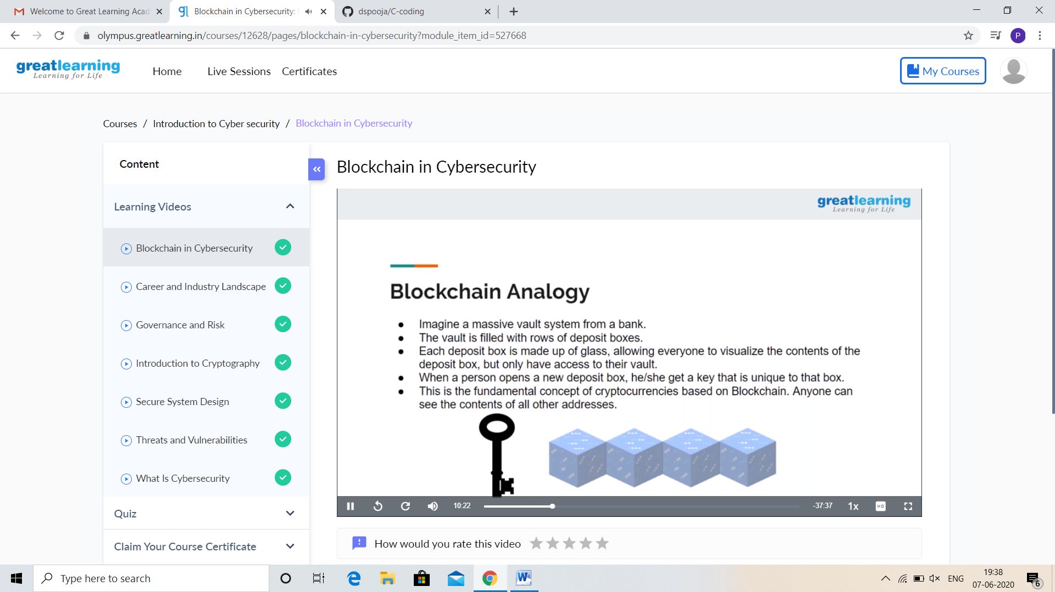

CODING CHALLENGES DETAILS:

Problem statement 1:

Write a C++ Program to swap two numbers using friend as a bridge concept.

Note- Don't make use of temp variable while swapping. Program should use the concept of **friend function**  
***Example***

**Input**  
a=10  
b=20  
**Output**  
a=20  
b=10

Solution: Uploaded it in github

